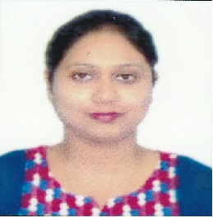
Curriculum Vitae

Career Objective: To curve out a special place in the field of service that help me to attain greater in my career.

Personal Profile:
Name: Indrani Saikia Chetia
Father Name: Putul Saikia
Mother Name: Archana Saikia
Date of Birth: 16th August 1990
Qualification: Mba(HR & Marketing) M.COM(Accountancy)
Address: Tipling Road Near WSS Duliajan, Dist – Dibrugarh, Assam-786602
E-Mail: indrani6162@gmail.com

Educational Qualification:
- Passed HSLC From SEBA Board(St. Xaviers School,Duliajan) in the year 2006 with 65%
- Passed HS(Commerce) From CBSE Board(DPS, Duliajan)in the year 2008 with 60.8%
- Passed B COM from Guwahati Commerce College under Guwahati University in the year 2011 with Accountancy Major(53.28%)
- Passed MBA from GIMT Guwahati under Guwahati University in the year 2013 with HR & Marketing specialisation(8cgp)
- Passed M.Com from IDOL under Guwahati University in the year 2014 with Accountancy major(51.23%)

Computer Qualification
- Advance Diploma in Computer Application(1year)

Experience
- Counselor cum Faculty in HITEC Computer Institute Duliajan(Sept 2013 to Dec 2014)
- Accountant cum Computer Operator in PNRD, Govt of India(January2015 to July 2015)
- Customer Assosiate Manager(bancassurance)HDFC Life(August2015 to October2016)

Certification
I, the undersigned certify that the resume correctly describes my qualification and myself.

Place: Duliajan
Name Indrani Saikia Chetia

Ph no 9127050934

